# Comparison between Azure AI and Google DOC AI

|  |  |  |
| --- | --- | --- |
| **Services Offered** | **Google DOC AI** | **Azure Doc Intelligence** |
| OCR / Read | Yes | Yes |
| Layout Parsing | Yes | Yes |
| Key-Value Pair Extraction | Yes | Yes |
| Bank Statement Parser | Yes | Yes |
| Pay Stub Parser | Yes | Yes |
| Invoice Parser | Yes | Yes |
| Receipt Parser | Yes | Yes |
| Identity Document Parser | Yes | Yes |
| W2 / Tax Form Parser | Yes (W2, W9) | Yes |
| Document Splitter | Yes (Lending, Procurement) | Yes |
| Utility Bill Parser | Yes | Yes |
| Business Card Parser | No | Yes |
| Custom Classification Model | Yes | Yes |
| Custom Extraction Model | Yes | Yes |
| Contract Parser | No | Yes |
| Credit Card Parser | No | Yes |
| Marriage Certificate Parser | No | Yes |
| Check Parser | No | Yes |
| Health Insurance Card Parser | No | Yes |
| Mortgage Document Parser | No | Yes |
| Custom Splitter | Yes | No |

* **Google Document AI has a Document Splitter** (including Lending, Procurement Splitters); **Azure does not provide a prebuilt Custom Splitter**.
* **Azure offers more prebuilt models** (Contracts, Credit Card, Health Insurance Card, Checks, Mortgage, Marriage Certificates) with **better accuracy and stable field extraction** out of the box.
* **Google prebuilt models can be uptrained** to add or customize fields; **Azure prebuilt models cannot be uptrained** (only custom models can be trained).
* **Azure prebuilt models are stable and production-ready** with clear schema; **Google’s prebuilt models are flexible and customizable**.

## Pay Stub Parser

Azure AI

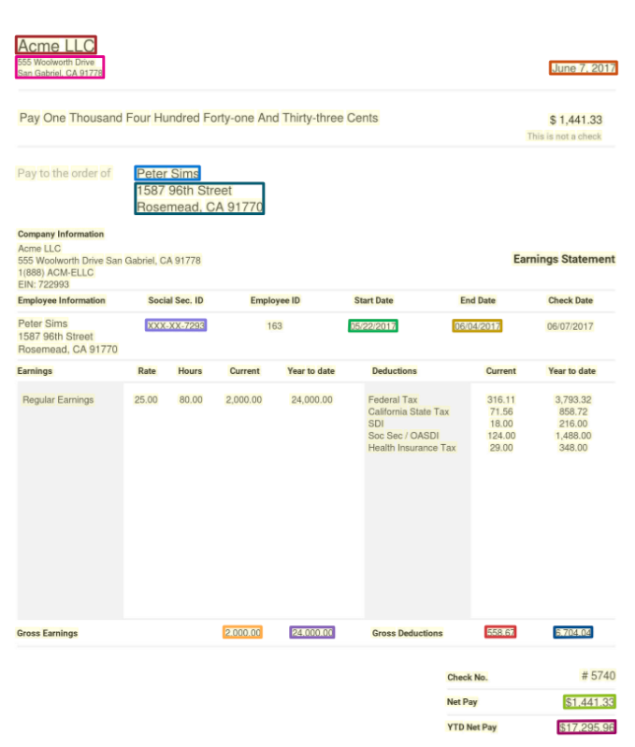

As seen no hours worked have been picked up.

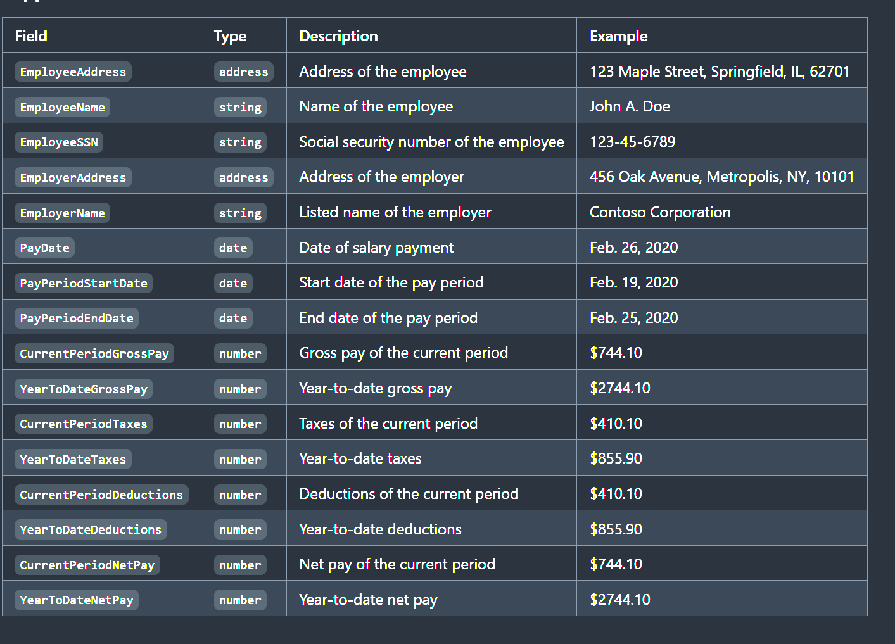

Fields with confidence score.

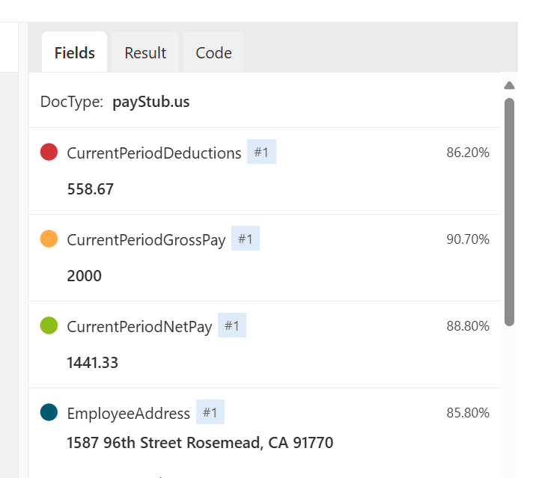 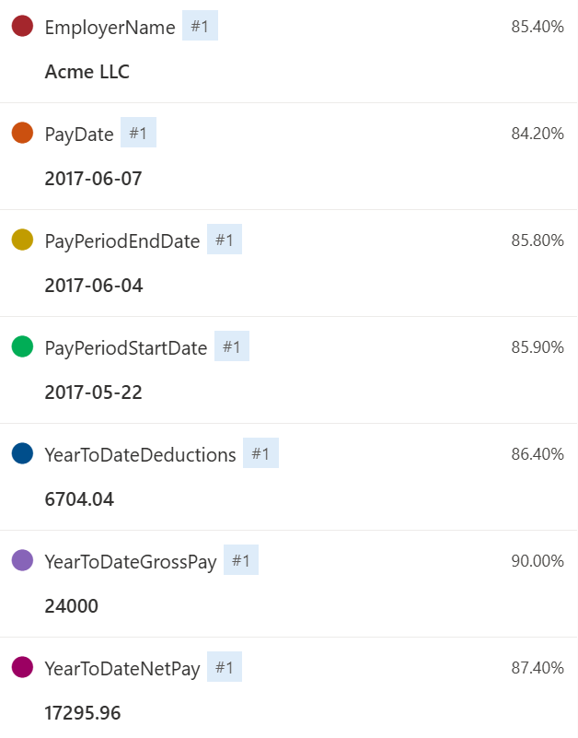

Google DOC AI

